What will we be learning?  Unit 1 - Body systems and the effects of physical activity | Why this? Why now?  This unit is externally assessed in January of Year 12 so studying this unit in the Autumn term prepares students for this examination. | Key Words:  Body system  Skeletal  Muscular  Cardio-vascular  Respiratory  Structure  Function  Short term exercise  Long term exercise
What will we learn?
The following body systems and the short and long-term effects of exercise on them:
- LO1 - Skeletal system
- LO2 - Muscular system
- LO3 - Cardiovascular system
- LO4 - Respiratory system
- LO5 - Energy systems
What opportunities are there for wider study?
Careers/degree courses
- Sports science
- Physiotherapy
- PE teacher

Further reading:
Human body systems: Overview, anatomy, functions | Kenhub
Effects Of Exercise On The Body - Short & Long Term - TeachPE.com
How will I be assessed?
- End of unit tests
- Mock exam
CAM TECH – SPORT
UNIT 1

SKELETAL SYSTEM  - Parts of the skeleton  - Functions of the skeletal system  - Types of bones  - Classification of joints  - Synovial joints – types, structure and functions  - Joint movements  - Vertebral column – structure and function  - Impact of exercise – short term, long term, how a warm up and cool down help | 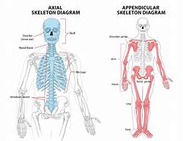
MUSCULAR SYSTEM  - Main muscles at synovial joints  - Muscle function and contraction  - Muscle fibre type and impact on performance  - Impact of exercise – short term and long term | 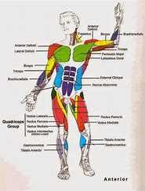
CARDIOVASCULAR SYSTEM  - The heart – structures and their roles  - Stroke volume, heart rate and cardiac output  - Blood vessels  - Blood – components and functions  - Vascular shunt mechanism and pre-capillary sphincters  - Impact of exercise – short term, long term and how a warm-up helps | 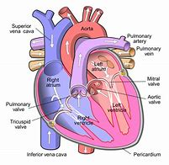
RESPIRATORY SYSTEM  - The lung – structures and their roles  - Mechanics of breathing and respiratory muscles used  - Gaseous exchange  - Tidal volume, breathing frequency and minute ventilation  - Blood – components and functions  - Impact of exercise – short term and long term | 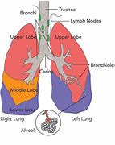
ENERGY SYSTEMS  - ATP-PC system  - Lactic acid system  - Aerobic system  - Energy continuum  - The recovery process | 